Research

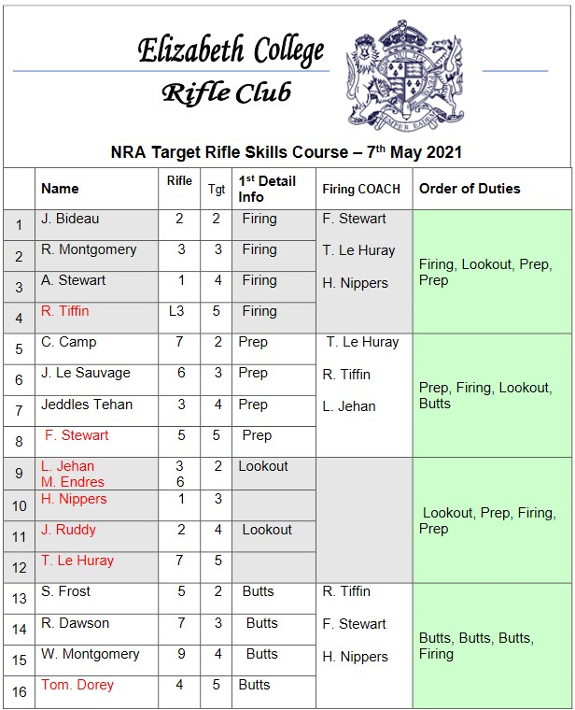

This is a good example of the current detail list format from the shooting squad, because it is formatted so that it shows all the information that is important for a training day.

Algorithm Research:

Combinational Optimization - <https://en.wikipedia.org/wiki/Combinatorial_optimization>

Assignment Problem - <https://en.wikipedia.org/wiki/Assignment_problem>

Database and Webhosting Research:

Google Firestore – <https://cloud.google.com/firestore>

Google Cloud - <https://cloud.google.com/>